Name | Vaishnavi Panmand
Roll no | 24204C0053
Batch | 3
Subject name | Python Programming & Data Structure
Teacher Name | Ms. Rasika Patil

Experiments | 12
Title | Implement searching techniques using python  a) Linear Search  b) Binary Search

Programming Questions with Answer
1 | Program for Linear Search
SCRIPT | # Linear Search Program in Python  def linear_search(arr, key):  for i in range(len(arr)):  if arr[i] == key:  return i # return index if element found  return -1 # return -1 if element not found  # Taking input from user  numbers = list(map(int, input("Enter elements separated by space: ").split()))  key = int(input("Enter element to search: "))  result = linear_search(numbers, key)  if result != -1:  print(f"Element found at index {result}")  else:  print("Element not found")
OP | 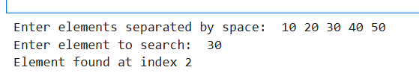
2 | Program for Binary Search
SCRIPT | def binary_search(arr, key):  low = 0  high = len(arr) - 1  while low <= high:  mid = (low + high) // 2  if arr[mid] == key:  return mid  elif arr[mid] < key:  low = mid + 1  else:  high = mid - 1  return -1  # Main Program  arr = [10, 20, 30, 40, 50, 60, 70] # Sorted array  key = 40  result = binary_search(arr, key)  if result != -1:  print("Element found at index:", result)  else:  print("Element not found")
OP | 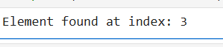
3 | Program to search for a character in a string (Linear Search logic)
SCRIPT | # Linear Search for a character in a string  string = input("Enter a string: ")  key = input("Enter the character to search: ")  found = False  for i in range(len(string)):  if string[i] == key:  print("Character found at position:", i)  found = True  break  if not found:  print("Character not found")
OP | 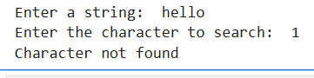
Debugging Questions with Corrected Answers
1 | Debug the following code  Wrong code:  arr = [1,2,3]  for i in arr:  if arr[i] == 2:  print("Found")
OP | Error: i already represents the element (1, 2, 3), not the index.  So arr[i] tries to access invalid index and causes IndexError.  Correct code:arr = [1,2,3]  for i in arr:  if arr[i] == 2:  print("Found")
2 | Debug the following code  Wrong code:  low = 0  high = len(arr)  mid = (low + high) / 2
OP | Error:arr is not defined.  Correct code:low = 0  high = len(arr)  mid = (low + high) / 2
Conclusion | Linear Search is simple and works on any list, but it is slower for large data.  Binary Search is faster and efficient, but it works only on sorted lists.
Performance Indicators |  | Teachers Dated and Signature
Process Related  (15 M) | Product Related  (10 M) | Total (25 M)

